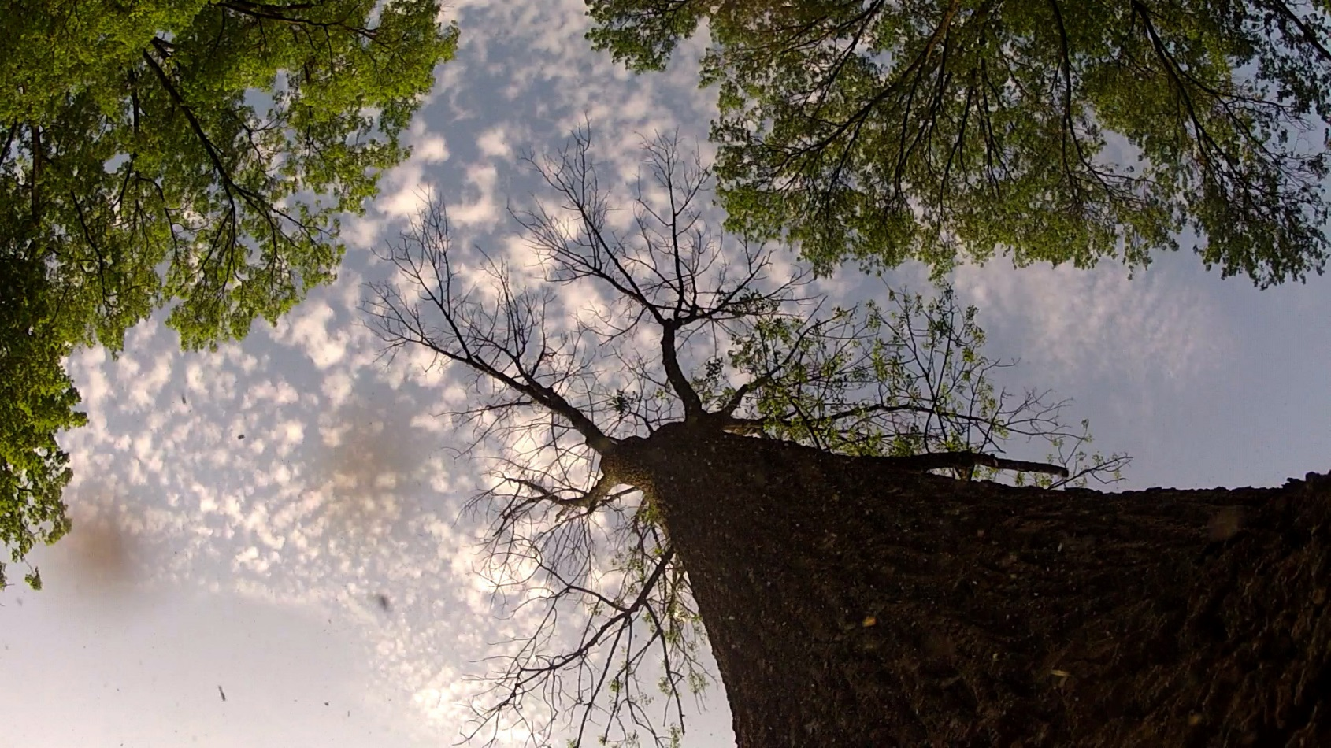
THE
TREES IN
TROUBLE
A documentary film about
saving our Community forests
by filmmaker Andrea Torrice

SCREENING
DATE:
TIME:
LOCATION:
For more information about the film: www.treesintrouble.com
*Sneak Preview of documentary that will be shown on PBS in Spring 2016

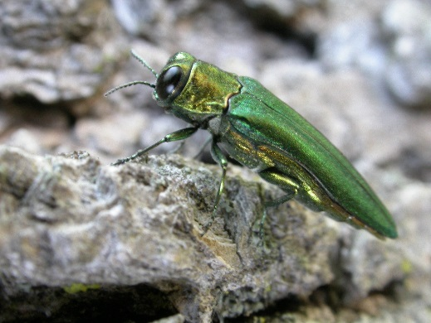 | 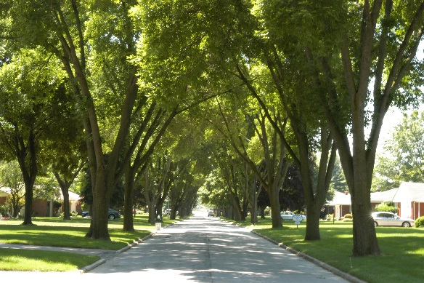 | 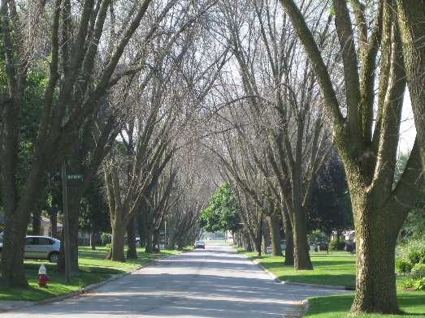
Emeral Ash Borer (EAB) | Before EAB | After EAB

